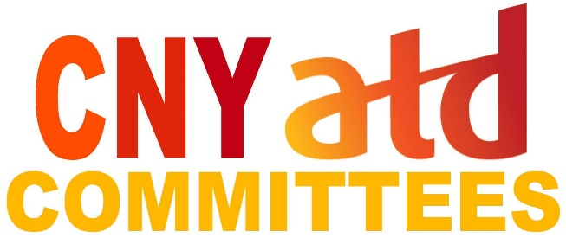  
**Volunteer Opportunities**

* [**Membership**](https://cnyatd.org/membership1) **Committee** – Strengthen CNY ATD through membership. Committee works on retention of current members, prospecting for new members, re-engaging past members, and orientation for new and prospective members. \**Meetings: Leadership Team strategic initiative as part of board meetings*
* [**CNY BEST**](https://cnyatd.org/cny_best) **Committee** – Recognize excellence in talent development in the local area. Committee works on the annual CNY BEST *Talent Development* program including awards process and ceremony. \**Meetings: 1st Tuesdays, 9-10am.*
* [**Train-the-Trainer (TTT)**](https://cnyatd.org/ttt) **Committee** – Provide for CNY ATD’s Train-the-Trainer programs. Committee works on content and delivery, trainer pool, and recruitment of participants for programs. \**Meetings: as desired.*
* [**Certifications**](https://cnyatd.org/certifications) **Committee** - Promote ATD’s certifications; Support members interested in certification; Support certified members. Committee works on certification promotion and support. *\*Meetings: as desired.*
* [**Programs**](https://cnyatd.org/programs) **Committee** – Provide formally developed learning and networking programs for CNY ATD. Committee works on identifying and selecting program topics, format and speakers, and coordinating program events. \**Meetings: 2nd Tuesdays, 9-10am.*
* [**Employee Learning Awareness (ELA)**](https://cnyatd.org/ela) **Committee** – Encourage awareness of employee learning in CNY area; Recognize Champions of Learning (COLs). Committee works on creating awareness of Employee Learning and encouraging organizations and individuals in CNY to become Champions of Learning. \**Meetings: 3rd Wednesdays, 8:30-9:30am.*
* [**Emerging**](https://cnyatd.org/emerging1) **Committee** – Facilitate the exploration of current and emerging talent development information. Committee works on approaches for exploring current and emerging talent development information (informal activities, curation, etc). \**Meetings: on hold.*
* [**Scholarship**](https://cnyatd.org/scholarship1) **Committee** – Encourage and support professional development and continuing education in the field of talent development. Committee works on developing criteria and guidelines for CNY ATD Scholarship applications and evaluations, and selection of scholarship recipients. Committee also works on fundraising efforts for scholarship fund. \**Meetings: 1st Wednesdays, 12:30-1:30pm.*

*\* Meetings held virtually using Zoom  
Periodically meetings may be held on different days or times, or in-person with virtual option*

**Get Involved!**

***Contact*** [***info@cnyatd.org***](mailto:info@cnyatd.org)

***with your name, email and committee interest***