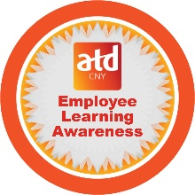

L e a r n i n g



|  |  |  |
| --- | --- | --- |
| Completed an e-learning within 7 days | Read an article related to work | Completed a classroom training within the last 6 months |
|  |  |  |
| List ________________________ | List ________________________ | List ________________________ |
| ___________________________ | ___________________________ | ___________________________ |
| ___________________________ | ___________________________ | ___________________________ |
| ___________________________ | ___________________________ | ___________________________ |
|  |  |  |
| Learning something new from a fellow associate | **Learning I plan**  **to complete!** | Learned a new skill within the past 6 months |
|  |  |  |
| List ________________________ | List ________________________ | List ________________________ |
| ___________________________ | ___________________________ | ___________________________ |
| ___________________________ | ___________________________ | ___________________________ |
| ___________________________ | ___________________________ | ___________________________ |
|  |  |  |
| Reviewed the company's learning opportunities | Attended a Webinar in the last 2 months | Assisted a fellow associate in learning a new skill |
|  |  |  |
| List ________________________ | List ________________________ | List ________________________ |
| ___________________________ | ___________________________ | ___________________________ |
| ___________________________ | ___________________________ | ___________________________ |
| ___________________________ | ___________________________ | ___________________________ |
|  |  |  |

**Name:**

**Instructions:** For every square, list accomplishments. Once completed,

hand in your Bingo card to the Talent Development Department

to be entered into the Employee Learning drawing.