Welcome  This month’s issue includes a synopsis of the last York Courts meeting, updates on ongoing projects within the courts, along with a list of our many exciting upcoming events.  We’d still like to include a bio column that will highlight a York Courts homeowner. If you’d like to let your neighbors know a little bit about yourself, please include a brief bio and picture. Again, If there is something you’d like to see in future issues, please e-mail Phil Reely at PhilReely@aol.com.  ___________________________________________  York Courts Signs Add A Touch of Elegance  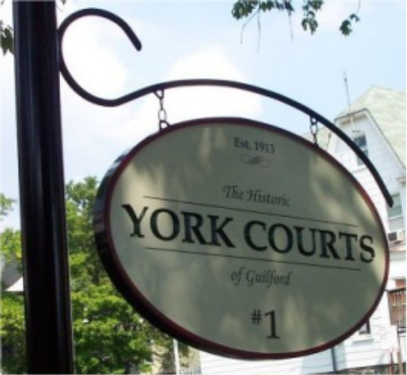  The York Courts of Guilford Signs Project has been completed! Our classy new signs have made a spectacular addition to the courts, calling attention to the lovely community we are all working so hard to improve and maintain.  Local leaders, surrounding community members and visitors along the York Road corridor have made special efforts to contact residents of the (see SIGNS on page 4)  YCoG Annual Picnic Brings Together Friends and Neighbors  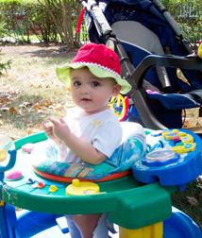  Neighborhood residents and folks around the Guilford community turned out for this year’s YCoG Annual Picnic in September. Also in attendance were many friends from outside York Courts who assisted with projects throughout the year.  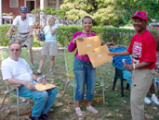  We were all happy to see a few new faces, and everyone in attendance enjoyed comfortable weather, great conversation and an array of wonderful food provided by the participants.  Property Improvements  First, we wish to thank our neighbors for their increased attention to maintaining the appearance and passage of the walkways between the courts.  We are continuing to investigate options for column repair in Court #2.  Column Repair Status  Phil still needs to follow-up with Mary at court #2 and potential is to find out whether the concrete company being contacted for sidewalks can do this and how much it will cost  Information about concrete company that did the sidewalks in court #1 a few years ago is being identified as potential cement company for GA to use.  ___________________________________________  Calendar of Events  Saturday, December 3, 6 p.m.  YCoG Holiday Tree Lighting  (hosted by Sharon and Charles Halm, 7 York Court #1)  Holiday lights are beginning to twinkle all over town, and the Courts are no exception! This fun annual celebration will commence with the official tree lighting and champagne toast in court #3 at 6 p.m. Then we’ll head over to Court #1 for food and festivities. Please bring your potluck contribution and libations! R.S.V.P. to the Halms at 410-366-5719, and let them know what you will be adding to the menu.  Sunday, December 4, 2005, 6 – 9 p.m.  Annual Guilford Women’s Civic League Cocktail Party  4100 Greenway, home of Sharon and Paul Smith  Wednesday, December 7, 6:30 pm  York Road Partnership Potluck Dinner  (St. Mary’s Church)  Since YCoG has received significant recognition over the past year from the YRP board and members, this is a great opportunity to step out and meet those who support our efforts. And of course it’s a great excuse to share food and fellowship with all your wonderful neighbors—and maybe make some new friends, too! | Alley Issues  The alley behind the courts continues to be rather crowded, and rest assured we are working to address these issues at our meetings. Trash days are especially problematic when cars block the passage of sanitation vehicles.  We have discussed several options for dealing with alley issues, including:  - No parking during certain hours on trash pick-up days  - Designing and implementing parking lines  - Instituting permit parking  We invite all residents to weigh in on these ideas, which we will review in detail and discuss further at our next meeting. In the meantime, Anne Dugan and Michael Bracey are looking into the issues and will collect input on a solution. If you have any suggestions, please contact Anne at 20 York Court #2 or Michael at 25 York Court #3.  It has become clear that the alley is again in need of repair. Phil Reely has agreed to contact city officials with a request to review and provide maintenance; he has sent e-mail to Tiffany James at the Mayor’s Office of Neighborhoods, Mary Pat Clarke and Howard Friedel.  Speeding through the alley is also a major concern—please consider the safety of your neighbors and their pets when you drive behind the courts.  ___________________________________________  York Road Name Extension Project  The work continues as we pursue changing the name in front of the three courts from Greenmount Avenue to York Road. Sharon Halm and Laura Amos are providing assistance in updating the property ownership list, and Donna Morgan is crafting a letter for nonresident owners. We currently are seeking volunteers to go door-to-door for petition signatures. If you are interested, please call 410.235.3860. Community awards from Mary Pat Clarke and Ann Marie Doorey were presented to various residents in  recognition of their volunteerism, along with Certificates of Appreciation from the courts.  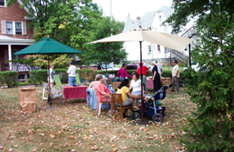  More photos on page 4.  __________________________________________  Court Captains  Your Court Captains are here to help! Please contact the following individuals if you have any questions or concerns within your court:  #1 – Sharon Halm, 7 York Court #1, 410-366-5719  #2 - Egbert Bunbury, 23 York Court #2, 410-662-8370  #3 - Phil Reely, 25 York Court #3, 410-235-3860  Hosts Needed  YCoG sends a special thanks to Laura Amos for hosting our November meeting. If anyone is interested in hosting future meetings, please contact your court captain.  YCoG Meetings  Our regular court meetings will be held the first Tuesday in February, May, August and November. If you have any concerns about this schedule, we would welcome your feedback. Please call Phil Reely at 410-235-3860.  ___________________________________________  New Residents and Properties for Sale  YCoG welcomes a new neighbor who recently purchased #34. We hope you’ll stop by and welcome him/her/them to our community.  Also, #36 is also for sale, and the price is down to $195K. A property in court #1 may be on the market soon. So let your friends know about these great opportunities to own a reasonably priced home in a great community with wonderful neighbors!  York Road Partnership E-Cycling: It's Electric!  Did you know that free, year-round electronic recycling is now available for city residents? This includes televisions, computer monitors, desktops, laptops, printers, scanners, DVD and VCR recorders, fax machines, PDAs, tape recorders, keyboards, mice, external disk drives, computer speakers, modems, remotes and cables. Special bins for electronic recycling available at the following drop-off locations, open Monday through Saturday, 9 a.m. to 5 pm.:  Quarantine Road Sanitary Landfill  6100 Quarantine Road  Western Sanitation Yard  701 Reedbird Avenue  Northwest Transfer Station  5030 Reisterstown Road  Eastern Sanitation Yard  6101 Bowleys Lane  Northwest Sanitation Yard  2840 Sisson Street  For more information, please call 410-396-8450.
Signs (cont’d from page 1)
have made special efforts to contact residents of the  courts to let us know just how much they like the new signs. In fact, several local communities have inquired about the contractors we used as they work toward having their own signs installed.  The YCoG Signs project was made possible with grants provided by the Greater Homewood Community Corporation. We also send our warmest and deepest thanks to the following residents for their time and effort: Laura Amos, Michael Bracey, Sharon Halm, Monroe Johnson, Leroy Von Hendricks and Michael Keevican. We are also grateful to the Sign King and Harbor Metal Works for making this project possible.  Please accept our apologies if we have forgotten anyone—everyone’s efforts are very much appreciated.  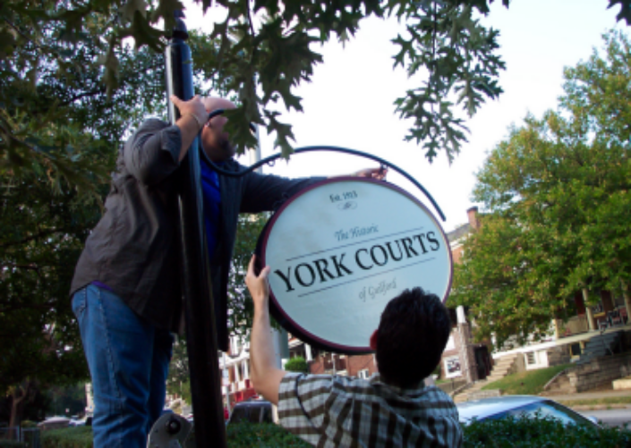 | 

